Questions to Ask a Caterer
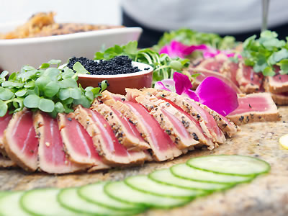
Besides your location, your wedding catering (food and bar) will probably consume the largest portion of your wedding budget. Catering costs are usually presented as “per-person” charges. But the per-person charge often doesn’t include everything: Tax and the gratuity might be extra, and there may also be separate per-person charges for the meal, drinks, hors d’oeuvres, and even setup. So your actual per-person charge might end up being considerably more than you expect. When meeting with potential caterers ask them for the real bottom line cost.
There’s more to consider. The Palms Catering offers a range of services in addition to catering. Some examples are: providing props, special effects, décor—in other words, complete event design. They might also be able to assist in finding a location, coordinating your affair, or lining up vendors. One thing a caterer can’t do, however, is cook up a 5-course Beef Wellington dinner for $20 per person. When planning your menu, be realistic about what you can serve given your budget and the size of your guest list.
A lot of factors come into play when selecting a caterer, so don’t be afraid to ask as many questions as you need to. We have provided following list for your use. This is a partial list. The Palms will provide you with a full list after your initial contact. Answers from The Palms are in red text.

The Basics
- Do you have my date open? Availability confirmed at time of contact.
- How many weddings do you do per year, and how long have you been in business? We cater an average of 25 weddings per year, ranging from 150 to 500 guests, and have been in business since 2004.
- Have you done events at my location? TIP: If you haven’t chosen your location yet, ask the caterer if they can help you select one. Depends on your venue.
- Are you licensed by the state of South Carolina? Are you licensed to serve alcohol? Yes. We provice certified and licensed bartenders.
- Will I need any permits for my event? If so, will you handle obtaining them? Yes.
- Will you provide a banquet manager to coordinate the meal service or an on-site coordinator who will run the entire event? Yes. Our reputation depends upon the quality of food and service provided and we will guarantee to provide the highest quality staff to ensure you are provided the best service available for your event.
- Can you assist with other aspects of the wedding like selecting other vendors, event design (e.g. specialty lighting, elaborate décor, theme events, etc.)? Yes.

Food & Presentation
- Given my budget, guest count and event style, what food choices would you recommend? Do you specialize in certain cuisines? Recommendations will be made when we meet to create a unique menu to match your style and budget, and we specialize in a variety of cuisines.
- Do we have to work off a preset menu or can you create a custom menu for our event? If I have a special dish I’d like served, would you accommodate that? We have no preset menus. We prefer to create a custom menu to accommodate any special requests you may have and meet your targeted budget.
- Do you offer event packages or is everything à la carte? What exactly do your packages include? Instead of packages, we customize each menu to create a unique menu based on your food choices and targeted budget.
- Do you use all fresh produce, meat, fish, etc.? Yes. Our reputation depends upon out quality of food!
- Can you accommodate dietary restrictions, such as kosher, vegan, etc.? Yes.
- What décor do you provide for appetizer stations or buffet tables? When meeting with our potential clients, we obtain color schemes, themes, etc. and coordinate food service tables and stations with your chosen décor.
- Do you offer upgrades such as chocolate fountains, ice sculptures, cappuccino machines or specialty displays? Yes.
- Can you do theme menus (e.g. barbecue, luau, etc.)? Would you also provide the décor? Yes.
This sample Q&A is provided for your use. A complete 6 page Q&A sheet will be provided by The Palms Catering when we meet with potential catering clients, in addition to our catering contract, so that you will be in the know, with no surprises. Our goal is to provide you with “no worries” catering service!

