Catering Service
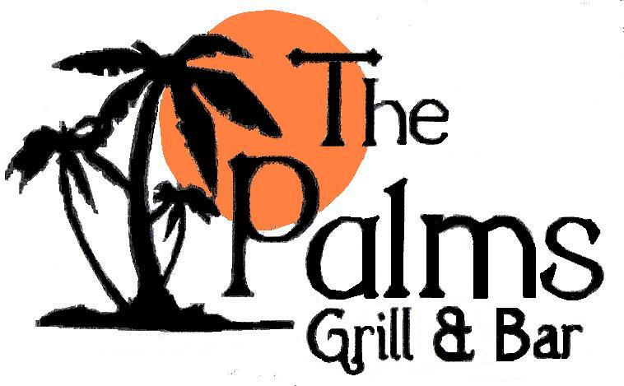 | 612 Wilson Road  Newberry, SC 29108  803-276-4688  Visit Us Online  www.thepalmsgrillandbar.com

We provide Full-Service & Drop-Off Catering!
Large or Small! Our Location or Yours!

Corporate Events & Business Meetings
Seated Dinners & Cocktail Receptions
Wedding Receptions & Rehearsal Dinners
Bridal & Baby Showers
Anniversaries & Birthdays
Holiday Parties
Reunions
BBQs
Oyster Roasts



Buffets or Sit Downs
Box Lunches
Sandwich Trays
Party Trays (Deli, Wings, Vegetable, Cheese, or Fruit)
Light or Heavy Hors D’oeuvres

Breakfast • Brunch • Lunch • Dinner

Choose your Favorites from our Restaurant Menu or
Collaborate with our Chefs to Prepare a Custom Menu for your Event.

Full Service Staffing &
License & Insured Bartending Services Available

Catering Excellence & Convenience at its BEST!
© 2010 The Palms Grill & Bar. All Rights Reserved.
Breakfast

Continental Breakfast

Assorted Fruit Tray
Bagels with Assorted Cream Cheese
Assorted Yogurt

Breakfast Buffet

Hash Browned Potatoes
Stone-Ground Grits
Bacon
Sausage Links
Scrambled Eggs
Toast
Assorted Fresh Fruits

Breakfast Menu Selections
Scrambled Eggs, Stone Ground Grits, Hash Brown Potatoes, Bacon, Sausage, Ham, Assorted Quiche, Breakfast Casserole, Breakfast Burrito with Salsa, Sausage Gravy, Biscuits or Toast with Butter & Jelly, Bagels with Cream Cheese, Pancakes with Syrup, French Toast with Syrup, Waffles with Syrup, Assorted Pastries, Assorted Danishes, Muffins, Doughnuts, Omelet Station, Assorted Yogurts, Assorted Cold Cereals, Fresh or Whole Fruits, Assorted Juices, Coffee, Tea, Milk

Lunch

Boxed Lunches and Trays

Sandwiches & Wraps
Sandwiches: Club, Ham & Swiss, Turkey & Provolone, Roast Beef & Cheddar, Cuban, Chicken Salad
Wraps: Turkey Bacon Ranch, Grilled or Fried Chicken Caesar, Grilled Chicken Southwestern

Served with Raw Fries, Pickle Spears, Cookies and Tea.
Add Potato or Pasta Salad for additional 50¢ per person

Deli Style Buffet

Deli Meat: Ham, Turkey, Roast Beef, Chicken Salad
Assorted Cheese: American, Provolone, Swiss, Applewood Smoked Cheddar
Bread: White, Wheat, Croissnats
Lettuce, Tomato, Onion and Pickle
Potato, Pasta or Garden Salad
Cookies or Brownies

Buffets
(Lunch or Dinner)

See our most popular buffet menus on following pages.

Southern Style Buffet

Entrée/Meat
Baked or Fried Chicken, Hamburger Steak w/Grilled Onions, Grilled Chicken Breast,
Salisbury Steak with Gravy, Grilled or Fried Pork Chops,
Turkey & Dressing, Spiral Glazed Baked Ham, Baked Tilapia, Stew Beef over Rice

Vegetables
Collards, Green Beans, Lima Beans, Stewed Squash,
Shoepeg Corn, Corn on the Cob, Sweet Peas, Steamed Broccoli,
Steamed Cabbage, Stewed Tomatoes, Speckled Butter Beans

Starch
Mashed Potatoes, Baked Potatoes, Potatoes Au Gratin,
Rice & Gravy, Brown Rice, Cornbread Dressing

Casseroles
Macaroni & Cheese, Sweet Potato Casserole, Squash Casserole, Broccoli Casserole,
Baked Potato Casserole, Green Bean Casserole
Bread
Dinner Rolls, Cornbread

Desserts
Peach Cobbler, Banana Pudding, Chocolate Cake

BBQ Buffet

Hickory Smoked Pulled Pork BBQ
BBQ Chicken
Rice & Hash
Baked Beans
Cole Slaw
Green Beans
Bread & Butter Pickles
Rolls

Contact us for a custom made Buffet Menu for your event.

HORS D’OEUVRES LIST
This is a sample list of our most popular Hors d’oeuvres and Food Stations/Bars.
We can accommodate most all food & station requests. Contact us for your requests or additional items not on this list.
Fruits  Cascading Diced Fruit Display  (With Pineapple Palm Trees)  Sliced Fruit Tray  Mini Fruit Kabobs with Dip  Chocolate Dipped Strawberries  Skewered Strawberries and Marshmallows  Seasonal Fruit Display with Chocolate Dip  Watermelon Basket with Seasonal Fruits  Chocolate Fountain with Fruit and Dippers  Vegetables  Fresh Vegetable Crudités (Tray & Dip)  Vegetable & Ranch Shooters  Grilled Marinated Vegetables  Prosciutto Wrapped Asparagus  Pimento Stuffed Cucumbers  Marinated or Grilled Vegetable Display  V Crispy Vegetable Spring Rolls with Dipping Sauce  Stuffed Mushrooms (Spinach, Sausage, and Other)  Open Faced Cucumber Rounds  Bacon Wrapped Water Chestnuts  Marinated Mushrooms or Asparagus  Cheese, Dips, Spreads and Dippers  Baked Brie Puffed Pastry  Domestic Cheese & Cracker Display  Imported Cheese and Cracker Display  Tortilla Chips & Salsa or Pico De Gallo  Cream Cheese Spread (Tuscan, Sweet Jalapeno,  Smoked Salmon, Pesto, Raspberry Chipotle Honey)  Humus (with Roasted Red Peppers, Roasted Garlic,  Cajun Spices, Sun Dried Tomatoes)  Bruschetta  Dip (Hot Artichoke, Southwestern, Mexican Tamale, T Hot Artichoke and Spinach, Grilled Asparagus and  Artichoke, Spinach, Crab, Layered Mexican, Rotel  Cheese, Avocado Cream, Onion, Nacho Cheese)  Cheese Ball and Crackers  Cheese Straws  Pimento Cheese & Toast Points  Chicken  Chicken Wings (Various Flavors Available)  Chicken Satay/Skewers (Various Flavors Available)  Chicken Tenders (Various Sauces Available)  Mini Chicken Kabobs  Roasted Chicken Drummettes  Chicken Quesadillas  House-Made Chicken Salad on Mini Croissants | Beef  Roast Beef on Petite Rolls  Shaved Roast Beef Platter with Rolls  Sliced Texas Beef Brisket on Petite Rolls  Beef Satay (Various Flavors Available)  Meatballs (Swedish, BBQ, Italian, Hawaiian)  Teriyaki Beef Tenderloin Kabobs  Miniature Hamburgers with Pickles and Ketchup  Filet Mignon Crostini with Horseradish Cream  Miniature Beef Wellington  Medallions of Beef  Steak Carpaccio  Inside Round of Beef on a Carving Station  Slow Roasted Prime Rib on a Carving Station  Pork  Pork Egg Rolls with Dipping Sauces  Pulled BBQ Pork Petite Rolls with Sauce  Glazed Cocktail Sausages  Garlic Roasted Pork Loin Medallions  Braised Boneless Short Ribs  Spiral Ham  Sliced Baked Ham with Biscuits or Rolls  Miniature Hot Dogs  Miniature Corn Dogs  Cocktail Smokies  Sausage Stuffed Mushrooms  Fish/Seafood  Shrimp (Peel & Eat, Popcorn, Fried Butterflied,  Coconut, Sautéed, Bacon Wrapped, BBQ)  Cocktail Shrimp in Shot Glass  Shrimp Skewers  Scallops (Seared, Bacon Wrapped)  Asian Tuna with Teriyaki Reduction  Assorted Sushi Platter with Wasabi and Ginger  Shrimp and Grits Martini Bar  Miniature Tuna Burgers with Wasabi Mayonnaise  Miniature Salmon Burgers with Dill Aioli  Smoked Salmon  Conch or Crab Fritters  Miniature Crab Cakes  Crab Wontons with Apricot Shallot Sauce  Crab Stuffed Mushrooms  Miniature Crab Cakes with Remoulade Sauce  Oysters on the Half Shell  Oysters Rockefeller  Fried Fish Bites with Tarter Sauce or Cajun Tarter
HORS D’OEUVRES LIST (Cont’d)
Salads  Tri-Colored Pasta Salad  Traditional Greek or Caesar Salad  Traditional Garden Salad with Dressings  Antipasto Salad  Broccoli Salad  Potato Salad  Chicken Salad  Shrimp Salad  Deviled Eggs  Miscellaneous  Fried Ravioli with Marinara Sauce  Sliced Beef, Ham and Turkey Platter w/Petite Rolls  Party Mix and Nuts  Assorted Mini Quiche  Petite Finger Sandwiches  Pizza Bites  Antipasto Skewers  Caprese (Basil, Mozarella) | Desserts/Sweets  Fresh Baked Cookie Assortment  Assorted Petite Desserts  Miniature Cheese Cakes  Bananas Foster  Brownies  Lemon Bars  Rice Crispy Treats  Cup Cakes  Pudding Shots  Yogurt with Granola & Fresh Fruit Cups or Shots  Beverages  Punch  Lemonade  Soft Drinks  Tea (Sweet & Unsweet)  Coffee (Caffinated & Decaffinated)  Bar  Open or Cash Bar Services. Wine, Beer, Liquor

STATIONS & BARS
ACTION STATIONS (ATTENDED)  Carving Station  * Served with rolls & choice of condiments  Inside Round of Beef Pork Loin  Spiral Cut Ham Prime Rib  Roasted Turkey Breast Beef Tenderloin  Omelet Station  Made to order omelets with diced ham, mushrooms, tomatoes, onions and green peppers.  Waffle Station  Made to order waffles with assorted toppings to include sliced strawberries, blueberries, sliced almonds, chopped pecans, powdered sugar and maple syrup.  Pasta Station  Cooked to order:  Pasta: Bowtie: Linguine, Angel Hair or Penne  Sauces: Marinara, Alfredo, Tomato Basil with Roasted Peppers, Pesto, Garlic Butter with Mushrooms, Meat Sauce, Vodka Sauce, Creamy Pesto, Herb Olive Oil with Roasted Garlic, Sambuca  Served with your choice of Grilled Chicken, Sautéed Shrimp, Roasted Vegetables, Red Crushed Pepper, and Parmesan Garlic Breadsticks.  Oriental Stir Fry Station  Choice of Shrimp, Chicken, Pork or Beef with Broccoli, Carrots, Mushrooms, Peppers, Bamboo Shoots, Water Chestnuts, Bok Choy, and Onions cooked to order with Steamed Rice and Fried Rice, Spring Rolls, Crab Wontons.  Tex-Mex Station  Grilled Beef, Shrimp and Chicken Fajitas with Onion and Peppers OR Beef and Chicken Nachos and Chips.  Ice Cream Station  Ice Cream with choice of toppings; Fruit, Nuts, Syrups, Crushed Cookies, Sprinkles served in Martini glasses, mini cones or cups.  Martini Tossed Salad Station  Fresh Garden Salad with your favorite dressings,tossed and served in a Martini Glass. | SELF-SERVE STATIONS  Mashed or Baked Potato Martini Station  Butter or Roasted Garlic Mashed Potato, Small Baked or Sweet Potato. Served in Martini Glasses with Butter, Roasted Garlic Butter, Herb Butter, Bacon, Sour Cream, Chives, Shredded Cheese, Brown Sugar, Mini Marshmallows  Shrimp and Grits Martini Station  Sautéed Shrimp, Creamy Grits, Tasso Gravy, Bacon Bits, Cheddar Cheese, Green Onions, Diced Tomatoes and Butter.  Seafood Station  Your choice from our Seafood list.  Fresh Raw Bar  Choose from Oysters on the half shell, peel & eat shrimp, boiled butterfly shrimp, shrimp cocktail, steamed crab legs, steamed or grilled lobster tails, steamed clams, Beaufort Stew, boiled corn-on-the-cob, lemon wedges, cocktail sauce, melted butter.  Sushi Station  Your choice of fresh assorted sushi. With Wasabi, pickled ginger and teriyaki sauce.  Cheese and Wine Bar  Your choice of domestic and/or imported cheese and wine.  Chocolate Fountain Station  White or Milk Chocolate with Fruit, Cake Cubes and Marshmallows.  Smores’ Station  Make your own smores’ using our flame unit with Graham Crackers, Marsh mellows, chocolate,  Dessert Station  Assorted Desserts from our Dessert list.  Hoagie Station  Ham, Turkey, Salami with lettuce, Sliced Tomatoes, Sliced onion, olive oil, oregano, Hot and sweet pepper, Mayo, Mustard. Potato Salad  Pulled Pork Martini Station  Traditional Carolina Barbeque layered with cole slaw and baked beans Topped with a mini corn muffin served in a martini glass.  Cajun Station  Jambalaya, Cajun BBQ Shrimp, Crawfish Cakes, Bourbon Chicken, Grilled Seasoned Zucchini & Onions  Slider Station  Hamburger, Crab Cake or BBQ Pulled Pork on Petit Brioche Rolls Accompanied by a Seasoned Potato Wedge, Remoulade Sauce, Ketchup, Sautéed Mushrooms, Onion, Cheddar and Bleu Cheese

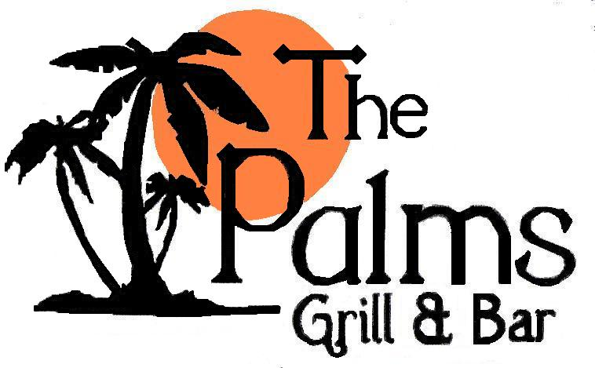 | Sample Catering Menus  These sample menus are from past catering services requests.  Each menu was tailored to the customer’s specific needs and preferences.  Therefore we have no predetermined menus; the choices are yours to make.
(Rehearsal Dinner)  Salad  Garden Salad  Served with assorted dressings.  Entrees  Prime Rib  Oven-Roasted and Seasoned Prim Rib with au jus for dipping and horseradish mayonnaise.  Knob Hill Chicken  Provolone Cheese, Black-Forest Ham, and Grilled Pineapple atop a Citrus Marinated Chicken Breast  Crab-Stuffed Tilapia  Served with a Tasso Ham and Shrimp Cream Sauce  All entrees include steamed vegetables,  roasted garlic mashed potatoes, dinner rolls, and  Tea, Water or Coffee |  |  | (Reception Party)  Assorted Sushi  Fresh-made Tuna, Shrimp, Crab Wrapped in  Rice & Seaweed, Served with Wasabi & Pickled Ginger  Crab Wontons  Crab-Stuffed Wontons with Apricot-Shallot Sauce.  Spring Rolls  Vegetable  Peel and Eat Shrimp  Boiled Shrimp with Cocktail Sauce  Asian Slaw  Marinated Cabbage  Full Service Bar with Assorted Wine and Beer Soft Drinks and Water
(Bridal Shower)  Chicken Salad  On Mini Croissants  Miniature Crab Cakes  With Remoulade Sauce.  Shrimp Cocktail  Boiled Shrimp with Cocktail Sauce  Vegetable Tray  Assorted Fresh Vegetables with Ranch Dressing  Fruit Tray  Assorted Fresh Fruit  Assorted Cookies  Tea, Soft Drinks & Water |  |  | (Breakfast Buffet)  Hash Browned Potatoes  Stone-Ground Grits  Bacon  Sausage Links  Scrambled Eggs  Toast  Assorted Fresh Fruits  Orange Juice, Coffee & Tea
Sample Catering Menus
These sample menus are from past catering services requests.
Each menu was tailored to the customer’s specific needs and preferences.
Therefore we have no predetermined menus; the choices are yours to make.

(Sandwiches & Wraps)  Assorted Sandwiches & Wraps  (Club Sandwiches, Chicken Salad on Croissants,  Turkey Bacon Ranch Wraps, Grilled Chicken Caesar Wraps)  Pasta Salad  (Italian style with, tomatoes, black olives and mushrooms)  Raw Fries  (Home Style Potato Chips)  Pickle Spears  (Kosher)  Brownies  (Housemade Chocolate Brownies)  Tea  (Sweet and Unsweetened) |  |  | (Chicken & Fish)  Grilled Chicken Breast  (Citrus Marinated Grilled Chicken Breast)  Baked Tilapia  (Baked in Herb Butter, Served with Lemon Wedges)  Wild Rice  (Steamed Rice with Vegetables)  Garden Salad  (Baby Spinach Leaves with Cherry Tomatoes, Red Onions and Fat-Free Vinegarette Dressing)  Assorted Fruit Trays  (Fresh Fruit-Strawberries, Cantaloupe, Honeydew, Grapes)  Tea & Water

(Pasta)  Baked Spaghetti  Chicken Alfredo  Caesar Salad  Garlic Bread  Italian Cream Cake  Tea & Water |  | (Kabobs)  Chicken Kabobs  (With Cherry Tomatoes, Mushrooms & Onions)  Rice Pilaf  (With Peas & Carrots)  Garden Salad  (With Assorted Dressings)  Rolls  Assorted Cookies  Tea & Water

Sample Catering Menus
These sample menus are from past catering services requests.
Each menu was tailored to the customer’s specific needs and preferences.
Therefore we have no predetermined menus; the choices are yours to make.

(Southern Style Buffet)  Grilled Chicken Breast  Hamburger Steak  Mashed Potatoes  Rice Pilaf  Green Beans  Steamed Vegetables  Dinner Rolls  Peach Cobbler  Tea & Water |  |  | (Southern Style Buffet)  Baked or Fried Chicken  Rice & Gravy  Green Beans  Steamed Cabbage  Macaroni & Cheese  Banana Pudding  Tea & Water

(Tex-Mex)  Fajita Station  (Steak, Shrimp, Chicken, Onions, Peppers, Mushrooms Sauteed to Order with Sour Cream, Cheese, Salsa & Guacamole toppings)  Spanish Rice  Southwest Cheese Dip & Chips  Grilled Vegetables  Taco Dip  Poppers  Apple Enchiladas  Tea & Water |  | (Steak & Chicken Buffet)  Grilled Ribeye Steaks  (Dry Rubbed and Grilled to Order)  Grilled Chicken Breast  (Marinated)  Baked Potatoes  (With Butter & Sour Cream)  Garden Salad  (With Assorted Dressings)  Bread  (Assorted Rolls)  Dessert  (Assorted Mini Cheese Cakes)  Tea & Water

Sample Catering Menus
These sample menus are from past catering services requests.
Each menu was tailored to the customer’s specific needs and preferences.
Therefore we have no predetermined menus; the choices are yours to make.
(Wedding Reception)

Carving Station
(Roast Beef with Rolls, Mayo, Mustard & Horseradish Sauce)

Seafood Station
(Peel & Eat Shrimp, Steamed Oysters on the Half Shell, Mini Crab Cakes, Sushi)

Steamed Vegetables
(Broccoli, Cauliflower & Carrots)

Spinach Dip
(Creamy Spinach Dip served with Crackers)

Assorted Domestic Cheese
(Applewood Smoked Cheddar, Swiss, Pepper Jack)

Assorted Fruit
(With Chocolate Fondue)

Beverage Bar
(Coke, Diet Coke, Sprite, Tea, Water)

Full-Service Bar
(Wine, Beer, Vodka, Gin, Rum, Bourbon)

(Wedding Reception)

Chicken Salad on Croissants
(House-Made Chicken Salad on Mini Croissants)

Grilled Vegetable Display
(Grilled Asparagus, Zucchini, Yellow Squash)

Meatballs
(Italian Style Meatballs)

Shrimp Skewers
(Bacon Wrapped BBQ Shrimp on 4” Skewers)

Mashed Potato Martini Station
(Mashed Potatoes served in Martini Glasses with Plain & Roasted Garlic Butter, Bacon, Sour Cream, Chives, Shredded Cheese)

Cascading Diced Fruit Display
With Pineapple Palm Trees
(Assorted Fresh Fruit with Marshmallow Dip)

Ice Cream Station
(Vanilla & Chocolate Ice Cream with Fruit, Nuts, Syrups, Crushed Cookies, Sprinkles, Served in Martini Glasses)

